User Manual
STL UH 232 & DD
Warning Working at height and the incorrect use of personal protective equipment is potentially dangerous. It is essential that the user reads these instructions and understands them before using this product. Training in the safe use of personal protective equipment is essential prior to using this equipment, training should be provided be a suitably qualified and competent person. To avoid personal injury, read and fully understand these instructions to ensure correct use. Safety Technology Ltd will not accept any liability for injuries or damage resulting from the incorrect use of this item.
All work at height should be accompanied by a suitable risk assessment and emergency action plan including rescue.

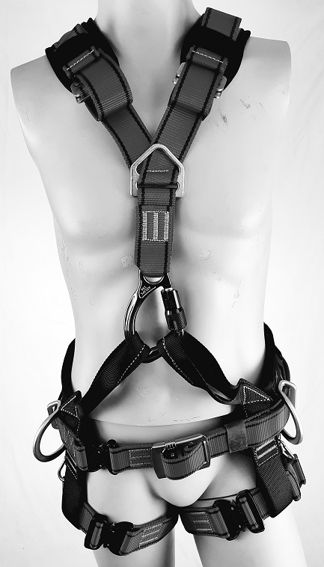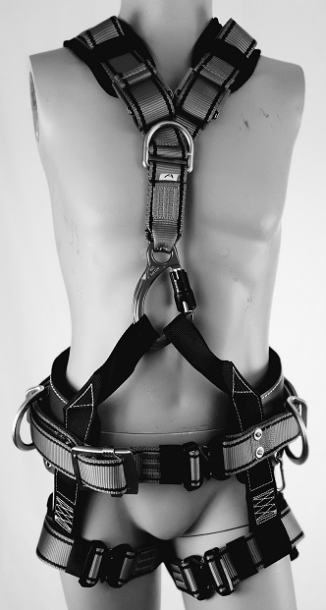

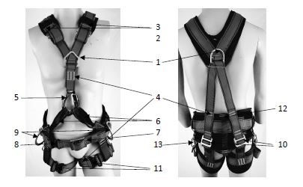
COMPONENT PARTS

- D-ring back and front for connection to fall protection systems; EN 355, EN 353-1/2, EN 360
- Adjustment for shoulder straps
- Webbing and lanyard holders
- Stitch patterns
- Carabiner for front closure of harness
- Webbing loops for harness closure and connection point for work suspension EN 813
- Non-slip adjustable buckle for securing waist belt
- Quick release buckle for ease of doffing and donning waist belt, (fig c)
- Side D-rings for work positioning EN 358
- Adjustment for leg strap length
- Leg strap adjuster buckle, (fig c)
- Fabric or leather waist belt
- Clips for tool bag attachment

The harness must be inspected prior to each use. If any items are found to be defective, take the harness out of service immediately. Components may not be substituted for others and the harness cannot be modified without prior approval of Safety Technology Ltd. Any modifications will negate the certification of this product.
PUTTING ON THE HARNESS
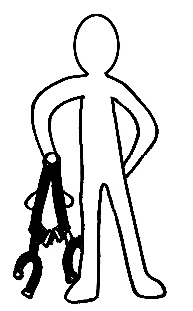
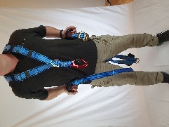 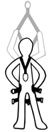    fig b 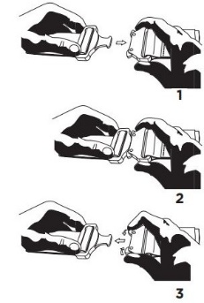fig c
Hold the harness by the rear D and allow to fall naturally without any twists to the webbing.
Place the Y yolk over the head ensuring that the front D is facing out from the body and there are no twists in the webbing.
Connect the waist belt and leg strap buckles, an audible click is needed for the quick release buckles (see fig c).
Clip the carabiner on the Y yolk to both webbing loops connected to the wait belt
Adjust the webbing to ensure the correct fit, not too tight as to restrict breathing or circulation and not too loose to allow excessive movement during a fall. Secure any loose webbing using the tabs provided

UH 232 and UH 233 DD full body harness has been designed and certified in accordance with EN standards EN 361:2002, EN 358:1999 and EN 813:2008 according to PPE Regulations (EU) 2016/425. The harness’ main purpose are to catch and hold the user in the event of a fall, or to hold and support the user to work hands free or in suspension. Only full body harnesses can be used to hold the body in a fall arrest situation. The harness is made from 45mm polyester webbing, metal components and either a fabric or leather waist belt. The maximum user weight including tools and other components must not exceed 150kg. A copy of the Declaration of Conformity can be found on the Safety Technology website www.safetytechnology.co.uk

Warning! All work at height requires that the user is medically fit, able to undertake the work required and is trained and competent to use the equipment. A risk assessment and rescue plan must be in place and understood prior to any work commencing. If you are unsure of what is required, contact Safety Technology Ltd for more information.

The harness is available in five sizes and prior to first use it should be fitted correctly to the user (see fig d). It is preferrable that each worker has their own issue PPE (ref EN 365). This fitting should be done in a safe location to ensure the harness is the correct size, fit and suitable for the work intended. During use it is necessary to check the fastening and adjustment regularly to ensure that no additional adjustments are needed.
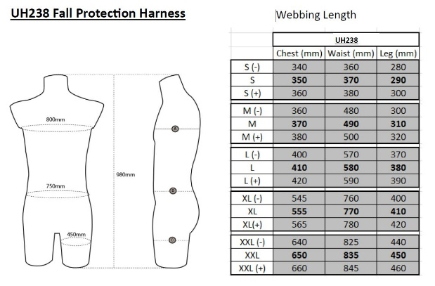fig d

The harness can be connect to (in accordance with EN 363:2008):
Fall protection systems such as energy absorbing lanyards, guided type fall arresters on flexible or ridged lines and self-retracting lanyards
Work positioning systems such as work positioning lanyards and ropes with ascent/descent devices
Restraint systems such as fixed or adjustable restraint lanyards
All components of these systems must be checked for compatibility and suitability, and the user must fully understand the functions of each component. These sub-systems must be approved for use in accordance with the applicable regulations. If assistance is needed, please contact Safety Technology Ltd. Using incompatible components or incorrect equipment can lead to potentially fatal consequences.

EN 361 Fall Arrest
As part of a fall arrest system (EN 363), the harness must only be connected at the sternal or dorsal D ring (item 1 on fig a) that are marked with an A. No other attachment points on the harness should be used for fall arrest. Attachment to these D rings should only be made with a connector that meets the requirements of EN 362:2004. A suitable anchor must be used as part of the fall arrest system and must meet or exceed the requirements of EN 795 i.e. 12kN. The anchor point should where possible be positioned above the user and all work done in manner that would minimise the risk or distance of a fall. Consideration must also be given to prevent a pendulum type movement in the event of a fall that could cause contact with any object, and that there is sufficient free space below the user to prevent any contact with any object during the deployment of any shock absorber.

EN 358 Work Positioning
The work positioning attachment points (item 9 on fig a) should not be used for fall arrest (falls greater than 0.6m), nor used as a method to suspend the user. Care must be taken to prevent the user being exposed to unintended tension from the waist belt. When using a work positioning system, it is usually used to support some of the user’s weight and therefore it is necessary to consider a fall arrest system as a back-up. The user must know how to correctly use the work positioning systems, how to connect them and ensuring that the systems are kept taunt during use. The chosen anchor point must be level or above the user.

EN 813 Sit Harness
The front black webbing loops (item 7 fig a) can be used together as a connection point for rope and work positioning systems. This is not to be used for fall arrest, only to connect descent devices, ropes, lanyards or work seats. Care must be taken to check for damage regularly

Inspection
The harness must be inspected before and after each use by the user and must also be inspected by a competent person approved by Safety Technology or their authorised manufacturers at intervals no greater than 12 months (EN 365), preferably at intervals not greater than 6 months (BS 8437). All parts of the harness must be check for damage and functionality and all markings must be legible, if any part is not fit for purpose, the harness must be removed from use immediately and either disposed of, or repaired by Safety Technology Ltd. If used in potentially adverse conditions, the harness should be subjected to additional formal inspection.

Maintenance
Along with regular inspection, to prolong the life of the harness it should be stored away from harmful substances such as corrosives, solvents, sharp edges, direct heat sources and UV radiation, damp environments and vibration. If dirty, the harness can be cleaned with normal soap or phosphate free detergent in water not exceeding 40°C and rinsed fully in clean water <40°C. When wet the harness must be hung to dry naturally and not dried using a heat source. Warning using harsh chemicals and high heat during cleaning can cause damage to the harness and potentially cause it to fail.

Hazards
The harness should not be used in extreme temperatures, in contact with sharp edges or abrasive substances, corrosive environments or where there is a risk of heat damage. Care must also be taken to ensure that components from other systems do not put the user at risk, such as trailing lanyards, loops that can be caught on moving objects, twin lanyards attached to an anchor and the harness at the same time.

Lifespan
With correct storage and maintenance this harness has a 10-year service life from date of manufacture, subject to ongoing inspection. Service life can be reduced through misuse, and it is the user’s responsibility to ensure that they understand the correct and safe use of this product.

Warning
If this product is to be re-sold in countries other that the UK, it is necessary that the reseller shall provide these instructions for use, care and maintenance in the language of the country in which the product will be used

UKCA evaluation certificate:
Satra Technology Ltd, Wyndham Way, Kettering Way, Kettering, Northamptonshire, NN16 8SD. Notified Body number 0321
CE evaluation certificate:
Satra Technology Europe Ltd, Bracetown Business Park, Colnee, Co. Meath, D15 YN2P Notified Body number 2777

EU/UKCA inspection and production control:
BSI Group The Netherlands B.V., John M. Keynesplein 9, 1066 EP Amsterdam, The Netherlands EU Notified Body No 2797
Markings
This product has a label for marking. The label shows the manufacturers name, contact number, product type, conformity, model, product code, size, date of manufacture, serial number, notified body number and warning to read the user instructions before use.

Model
Serial Number
Date of Manufacture
Date of first use
Date | Comments |  | Name and signature | Nest inspection

